CREATE TABLE EMP

(

Empno INT,

Empname VARCHAR(30),

Empsalary INT,

Deptname VARCHAR(30) NULL,

Bossno INT NULL,

PRIMARY KEY (Empno),

FOREIGN KEY (Bossno) REFERENCES EMP (Empno)

);

CREATE TABLE DEPARTMENT

(

Deptname VARCHAR(30) PRIMARY KEY,

Deptfloor INT,

Deptphone INT,

MgrId INT NOT NULL,

FOREIGN KEY (MgrId) REFERENCES EMP (Empno)

);

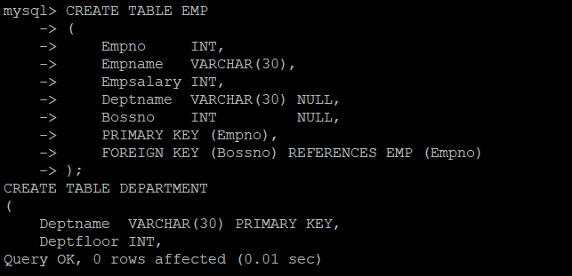

CREATE TABLE ITEM

(

itemname VARCHAR(30) PRIMARY KEY,

itemtype CHARACTER,

itemcolor varchar(10)

);

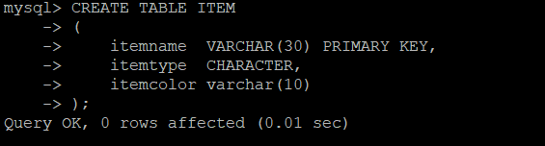

CREATE TABLE SALES

(

Salesno INT PRIMARY KEY,

Saleqty INT,

itemname varchar(30) NOT NULL,

Deptname VARCHAR(30) NOT NULL,

FOREIGN KEY (itemname) REFERENCES ITEM (itemname),

FOREIGN KEY (Deptname) REFERENCES DEPARTMENT (Deptname)

);

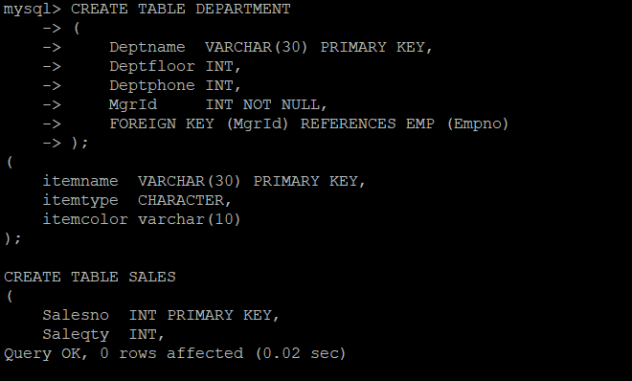

INSERT INTO EMP

VALUES (1, 'Alice ', 75000, 'Management', NULL),

(2, 'Ned', 45000, 'Marketing', 1),

(3, 'Andrew', 25000, 'Marketing', 2),

(4, 'Clare', 22000, 'Marketing', 2),

(5, 'Todd', 38000, 'Accounting', 1),

(6, 'Nancy', 22000, 'Accounting', 5),

(7, 'Brier', 43000, 'Purchasing', 1),

(8, 'Sarah', 56000, 'Purchasing', 7),

(9, 'Sophile', 35000, 'Personnel', 1),

(10, 'Sanjay', 15000, 'Navigation', 3),

(11, 'Rita', 15000, 'Books', 4),

(12, 'Gigi', 16000, 'Clothes', 4),

(13, 'Maggie', 11000, 'Clothes', 4),

(14, 'Paul', 15000, 'Equipment', 3),

(15, 'James', 15000, 'Equipment', 3),

(16, 'Pat', 15000, 'Furniture', 3),

(17, 'Mark', 15000, 'Recreation', 3);

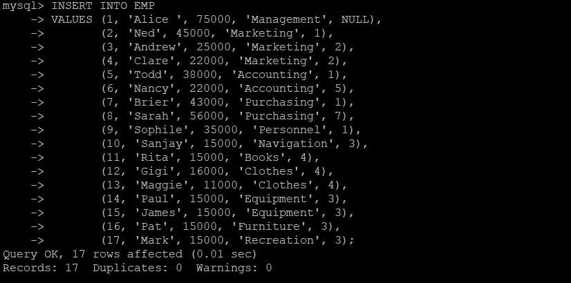

INSERT INTO DEPARTMENT

VALUES ('Management', 5, 34, 1),

('Books', 1, 81, 4),

('Clothes', 2, 24, 4),

('Equipment', 3, 57, 3),

('Furniture', 4, 14, 3),

('Navigation', 1, 41, 3),

('Recreation', 2, 29, 4),

('Accounting', 5, 35, 5),

('Purchasing', 5, 36, 7),

('Personnel', 5, 37, 9),

('Marketing', 5, 38, 2);

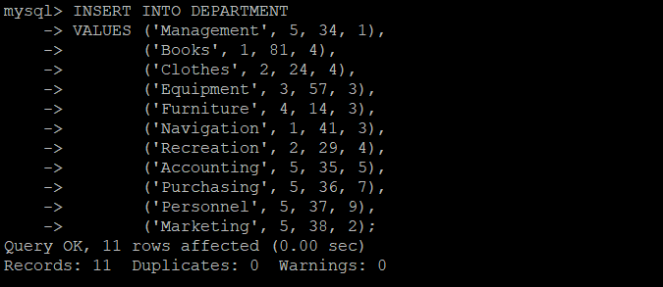

ALTER TABLE EMP

ADD FOREIGN KEY (Deptname) REFERENCES DEPARTMENT (Deptname);

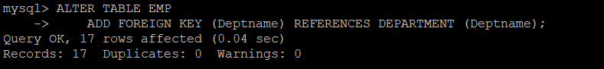

INSERT INTO ITEM

VALUES ('Pocket Knife-Nile', 'E', 'Brown'),

('Pocket Knife-Avon', 'E', 'Brown'),

('Compass', 'N', NULL),

('Geo positioning system', 'N', NULL),

('Elephant Polo stick', 'R', 'Bamboo'),

('Camel Saddle', 'R', 'Brown'),

('Sextant', 'N', NULL),

('Map Measure', 'N', NULL),

('Boots-snake proof', 'C', 'Green'),

('Pith Helmet', 'C', 'Khaki'),

('Hat-polar Explorer', 'C', 'White'),

('Exploring in 10 Easy Lessons', 'B', NULL),

('Hammock', 'F', 'Khaki'),

('How to win Foreign Friends', 'B', NULL),

('Map case', 'E', 'Brown'),

('Safari Chair', 'F', 'Khaki'),

('Safari cooking kit', 'F', 'Khaki'),

('Stetson', 'C', 'Black'),

('Tent - 2 person', 'F', 'Khaki'),

('Tent -8 person', 'F', 'Khaki');

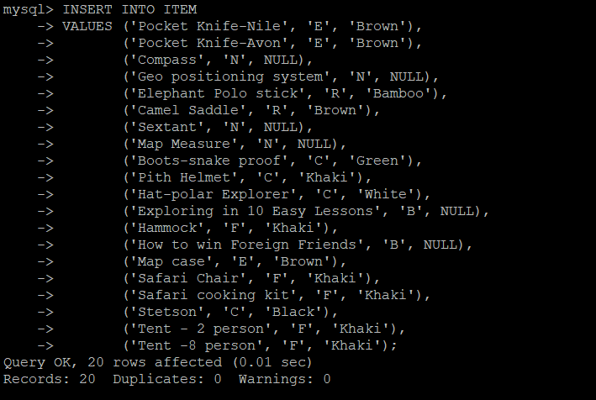

INSERT INTO SALES

VALUES (101, 2, 'Boots-snake proof', 'Clothes'),

(102, 1, 'Pith Helmet', 'Clothes'),

(103, 1, 'Sextant', 'Navigation'),

(104, 3, 'Hat-polar Explorer', 'Clothes'),

(105, 5, 'Pith Helmet', 'Equipment'),

(106, 2, 'Pocket Knife-Nile', 'Clothes'),

(107, 3, 'Pocket Knife-Nile', 'Recreation'),

(108, 1, 'Compass', 'Navigation'),

(109, 2, 'Geo positioning system', 'Navigation'),

(110, 5, 'Map Measure', 'Navigation'),

(111, 1, 'Geo positioning system', 'Books'),

(112, 1, 'Sextant', 'Books'),

(113, 3, 'Pocket Knife-Nile', 'Books'),

(114, 1, 'Pocket Knife-Nile', 'Navigation'),

(115, 1, 'Pocket Knife-Nile', 'Equipment'),

(116, 1, 'Sextant', 'Clothes'),

(117, 1, 'Sextant', 'Equipment'),

(118, 1, 'Sextant', 'Recreation'),

(119, 1, 'Sextant', 'Furniture'),

(120, 1, 'Pocket Knife-Nile', 'Furniture'),

(121, 1, 'Exploring in 10 easy lessons', 'Books'),

(122, 1, 'How to win foreign friends', 'Books'),

(123, 1, 'Compass', 'Books'),

(124, 1, 'Pith Helmet', 'Books'),

(125, 1, 'Elephant Polo stick', 'Recreation'),

(126, 1, 'Camel Saddle', 'Recreation');

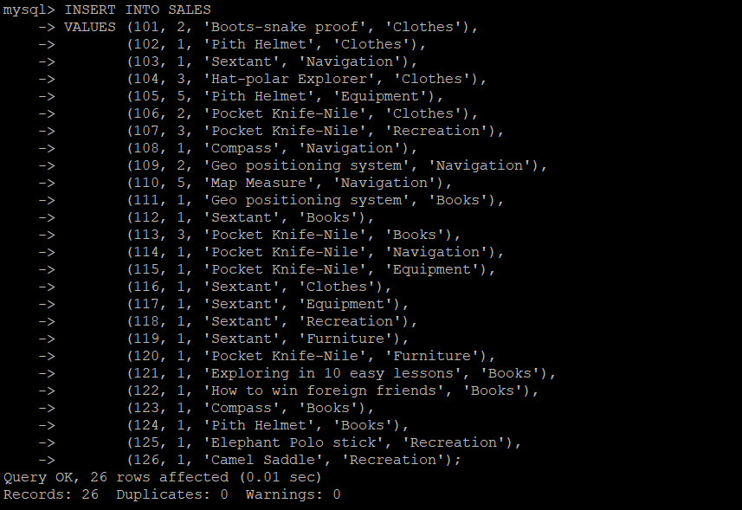

1)SELECT DISTINCT Deptname

FROM DEPARTMENT;

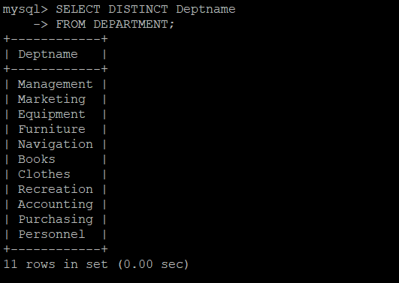

2)SELECT *

FROM EMP

INNER JOIN DEPARTMENT D ON EMP.Empno = D.MgrId;

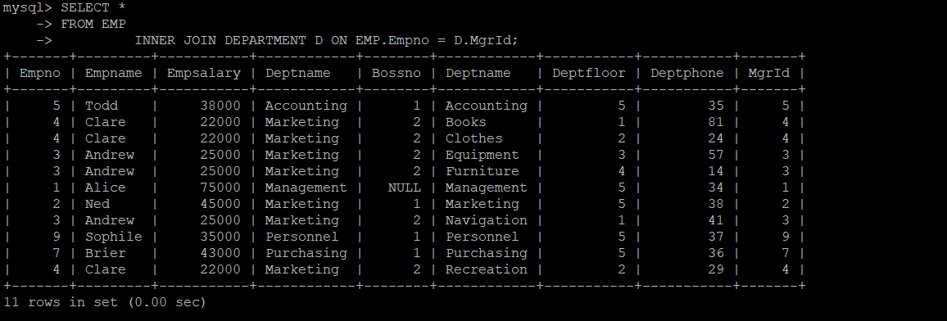

3)SELECT itemname, sum(Saleqty) AS 'Total Quantity'

FROM SALES

GROUP BY itemname;

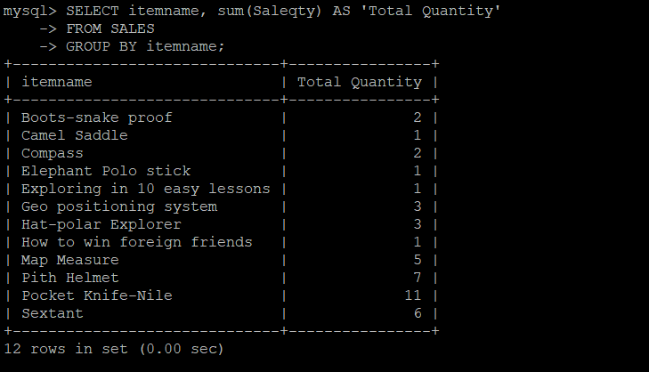

4)SELECT itemname

FROM ITEM

WHERE itemtype IN ('E', 'F');

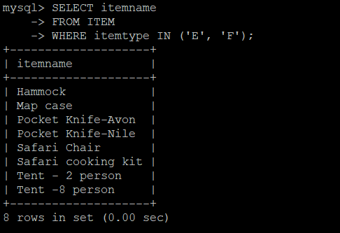

5)SELECT itemname

FROM ITEM

WHERE itemcolor IS NULL;

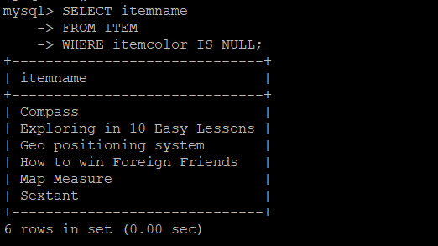

6)SELECT itemcolor, COUNT(*)

FROM ITEM

WHERE itemcolor IS NOT NULL

GROUP BY itemcolor

ORDER BY COUNT(*) DESC

LIMIT 1;

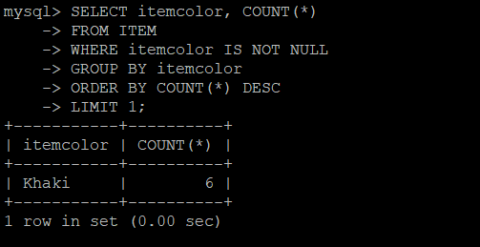

7)SELECT itemname

FROM ITEM

WHERE itemtype BETWEEN 'E' AND 'K'

AND itemcolor IN ('Kakhi', 'Brown');

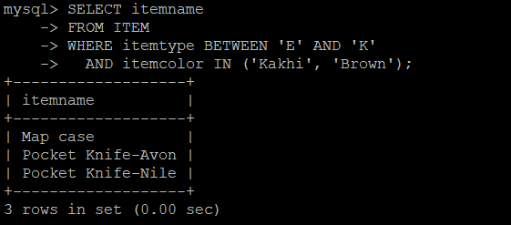

8)SELECT itemname

FROM ITEM

WHERE itemtype IN ('E', 'N')

AND itemcolor = 'Brown';

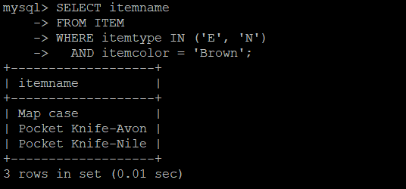

9)SELECT *

FROM ITEM

WHERE itemtype = 'R';

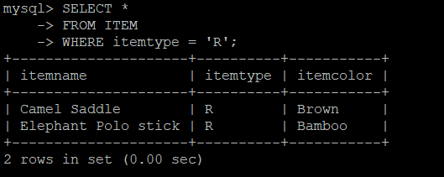

10)SELECT *

FROM ITEM

WHERE itemcolor = 'Red';

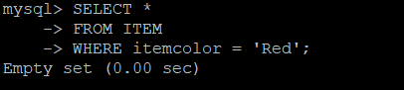

11)SELECT itemname

FROM ITEM

WHERE itemtype = 'C'

AND itemcolor = 'Red';

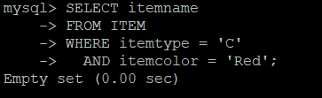

12)SELECT itemname

FROM ITEM

GROUP BY itemname

HAVING COUNT(DISTINCT itemcolor) > 1;

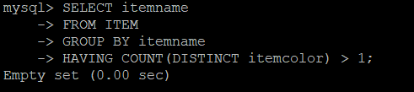

13)SELECT *

FROM ITEM

WHERE SUBSTRING(itemname, 1, 1) IN ('S', 'R');

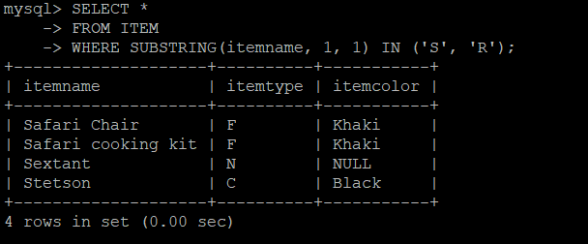

14)SELECT *

FROM ITEM

WHERE itemname LIKE '%Knife%';

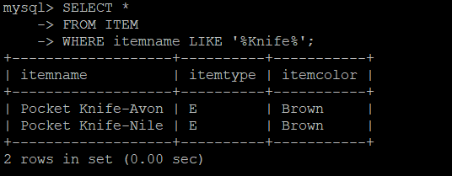

15)SELECT *

FROM ITEM

WHERE SUBSTRING(itemname, 3, 1) = 't';

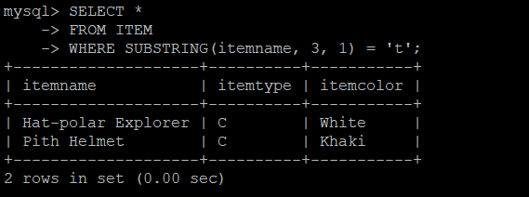

16)SELECT *

FROM ITEM

WHERE itemname IN (SELECT DISTINCT itemname FROM SALES WHERE Deptname = 'Clothes')

AND itemtype = 'C';

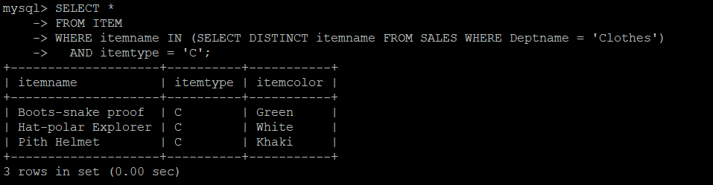

17)SELECT *

FROM ITEM

WHERE itemtype = 'C';

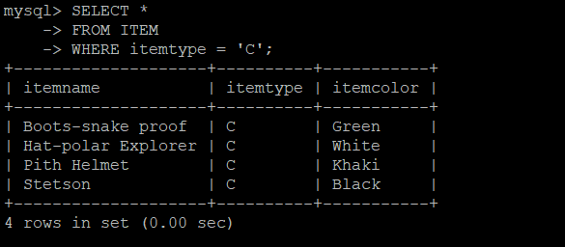

18)SELECT *

FROM ITEM

WHERE itemname NOT IN (SELECT DISTINCT itemname FROM SALES WHERE Deptname = 'Clothes')

AND itemtype = 'C';

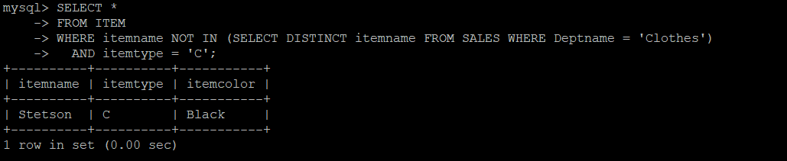

# QN 19

# TODO

20)SELECT *

FROM ITEM

WHERE itemcolor = 'Brown';

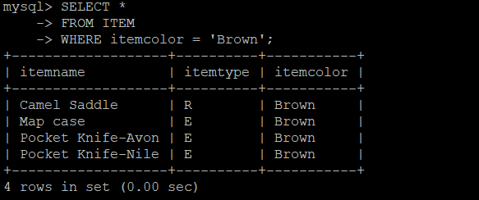

21)SELECT itemname

FROM SALES

WHERE Saleqty > 1;

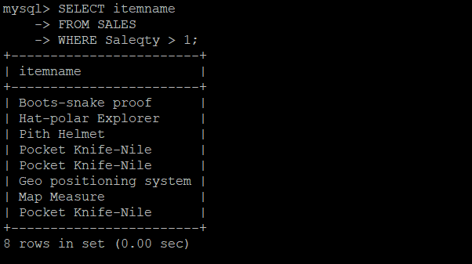

# QN 22

# TODO

23)SELECT itemname

FROM SALES

WHERE Deptname = 'Furniture';

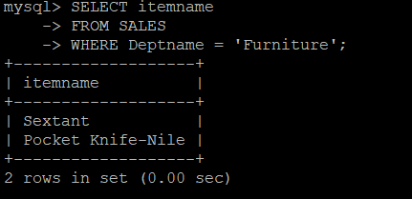

24)SELECT *

FROM ITEM

WHERE itemname IN (SELECT itemname FROM SALES WHERE Salesno BETWEEN 107 AND 112 OR Salesno BETWEEN 121 AND 126);

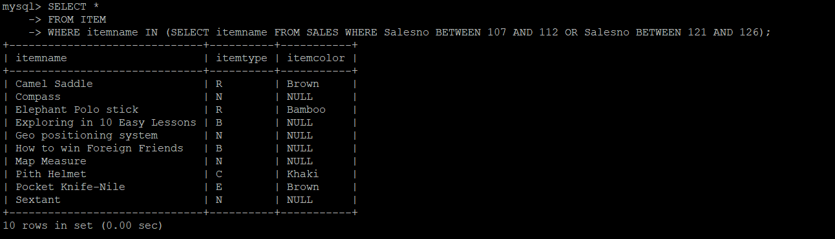

25)SELECT Deptname, SUM(Saleqty)

FROM SALES

GROUP BY Deptname;

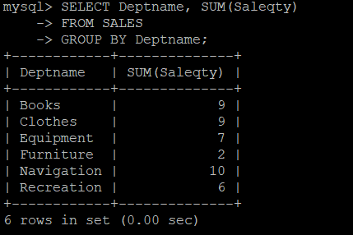

26)SELECT itemname

FROM SALES S

INNER JOIN ITEM I USING (itemname)

WHERE itemcolor = 'Green';

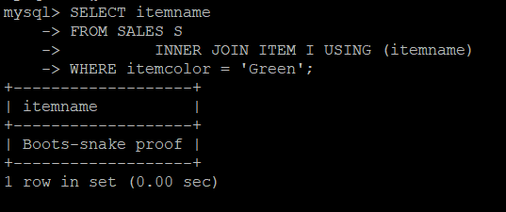

27)SELECT DISTINCT I.*

FROM ITEM I

INNER JOIN SALES S USING (itemname)

WHERE Deptname != 'Books';

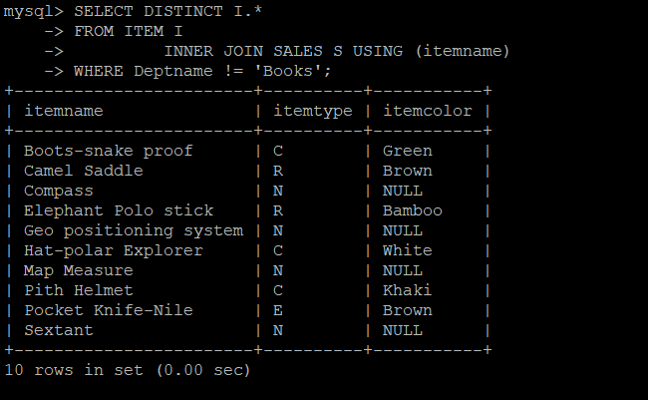

28)SELECT DISTINCT Deptname

FROM SALES

WHERE Deptname NOT IN (SELECT Deptname FROM SALES WHERE itemname = 'Geo positioning system');

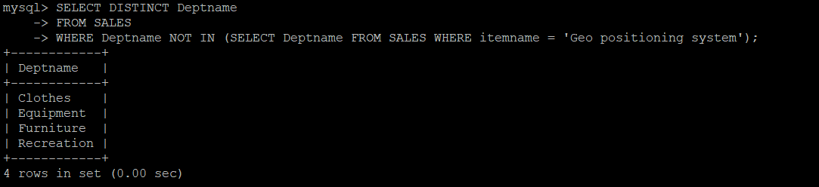

29)SELECT Deptname

FROM SALES

WHERE Deptname IN (SELECT DISTINCT Deptname FROM SALES WHERE itemname = 'Compass')

GROUP BY Deptname

HAVING COUNT(DISTINCT itemname) > 2;

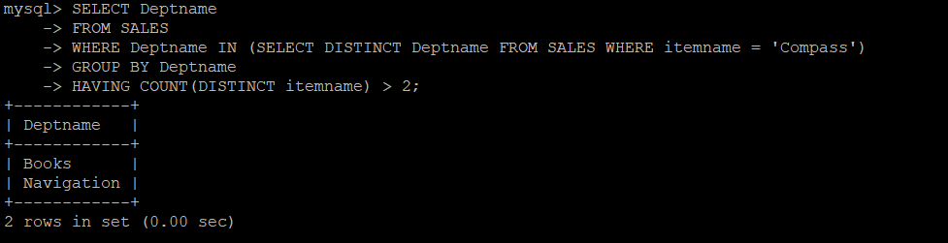

30)SELECT Deptname

FROM SALES

GROUP BY Deptname

HAVING COUNT(itemname) >= 4;

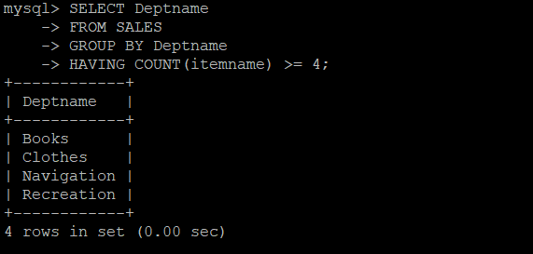

31)SELECT E.*

FROM EMP E

INNER JOIN EMP B ON E.Bossno = B.Empno AND E.Deptname != B.Deptname;

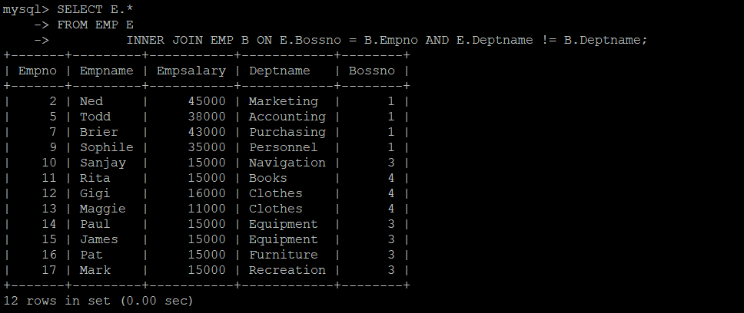

32)SELECT E.*

FROM EMP E

INNER JOIN EMP B ON E.Bossno = B.Empno AND E.Empsalary < B.Empsalary / 2;

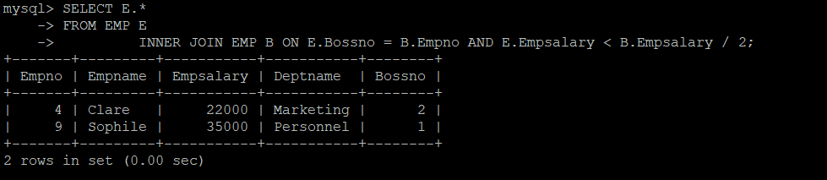

33)SELECT I.*

FROM ITEM I

INNER JOIN SALES S USING (itemname)

INNER JOIN DEPARTMENT D USING (Deptname)

WHERE itemcolor = 'Green'

AND Deptfloor = 2;

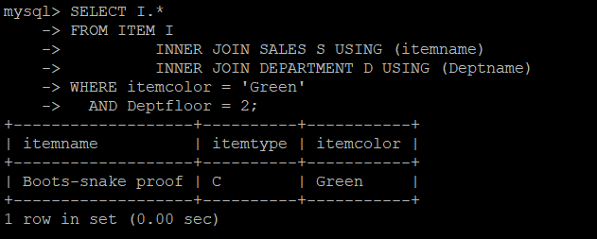

34)SELECT itemname

FROM SALES

GROUP BY itemname

HAVING COUNT(Deptname) >= 2;

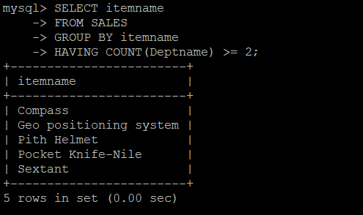

35)SELECT *

FROM SALES

WHERE Deptname NOT IN ('Clothes', 'Books');

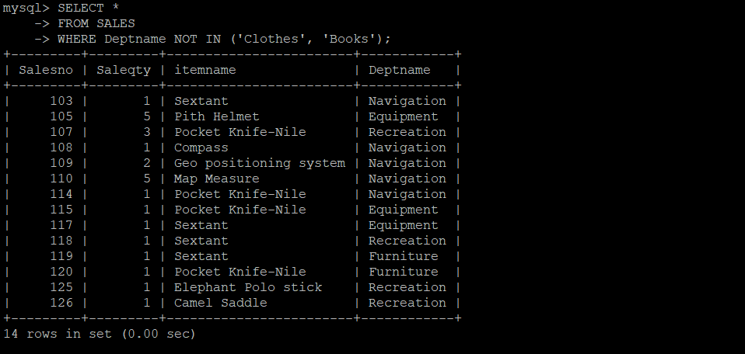

36)SELECT *

FROM EMP

WHERE Deptname = 'Marketing'

ORDER BY Empsalary DESC

LIMIT 1;

37)SELECT Empname

FROM EMP

WHERE Empsalary < (SELECT AVG(Empsalary) FROM EMP) * 0.9;

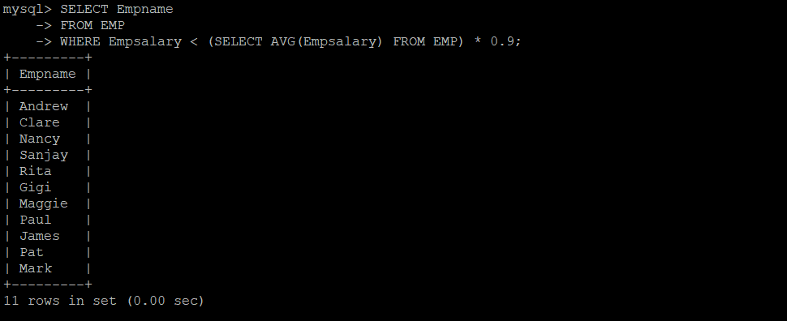

38)SELECT Empname

FROM EMP

WHERE Empsalary > (SELECT MIN(Empsalary) FROM EMP WHERE Empno IN (SELECT DISTINCT Bossno FROM EMP));

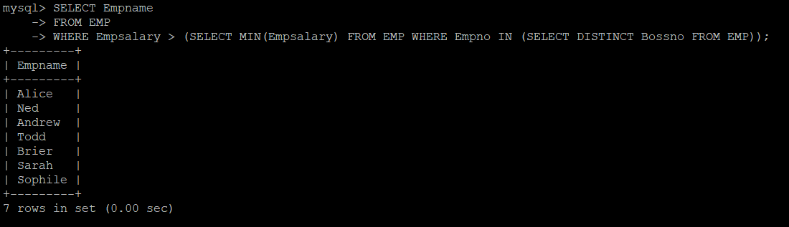

39)SELECT DISTINCT Deptname

FROM SALES

WHERE Deptname NOT IN (SELECT DISTINCT Deptname FROM SALES WHERE itemname IN ('Compass', 'Geo positioning system'));

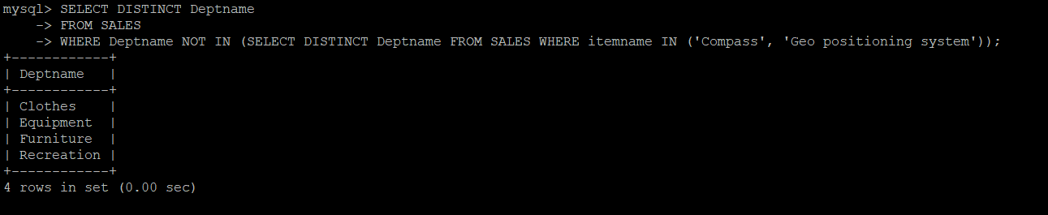

40)SELECT Empname

FROM EMP

WHERE Empsalary < 10000;

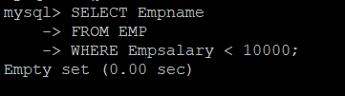

41)SELECT COUNT(*)

FROM ITEM I

INNER JOIN SALES S USING (itemname)

INNER JOIN DEPARTMENT D USING (Deptname)

WHERE Deptfloor = 3

AND itemtype = 'E';

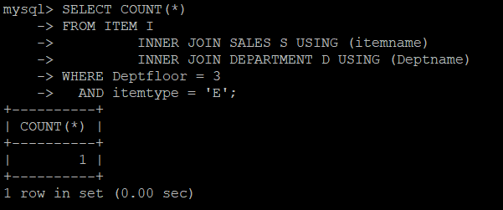

42)SELECT itemname, COUNT(*)

FROM SALES S

INNER JOIN ITEM I USING (itemname)

GROUP BY itemname;

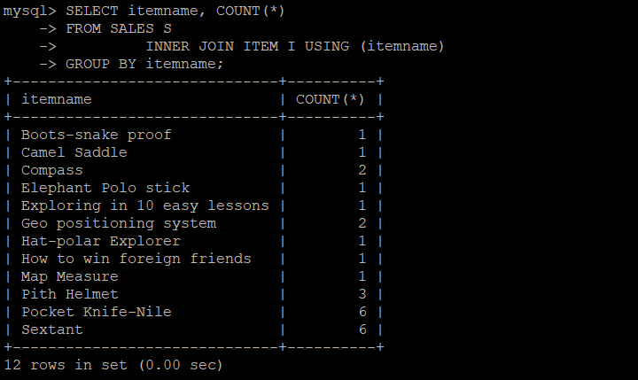

43)SELECT itemname

FROM ITEM

WHERE itemcolor = 'Green'

AND itemname IN (SELECT itemname

FROM SALES

GROUP BY itemname

HAVING COUNT(DISTINCT Deptname) = (SELECT DISTINCT COUNT(Deptname) FROM SALES));

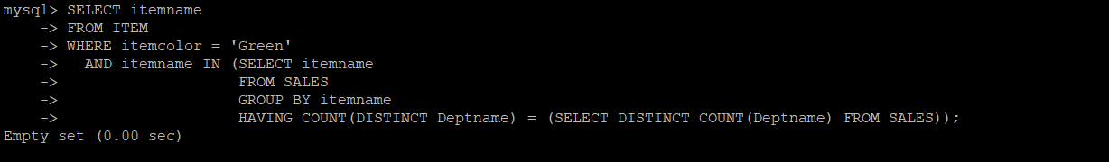

44)SELECT Deptname

FROM SALES

GROUP BY Deptname

HAVING COUNT(*) <= 1;

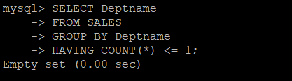

45)SELECT itemname

FROM SALES

GROUP BY itemname

HAVING COUNT(DISTINCT Deptname) = (SELECT COUNT(DISTINCT Deptname) FROM SALES);

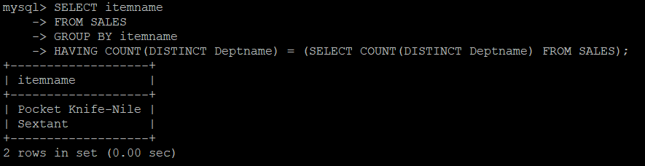

46)SELECT DISTINCT Deptname

FROM SALES

WHERE Deptname NOT IN (SELECT Deptname FROM SALES WHERE itemname = 'Compass');

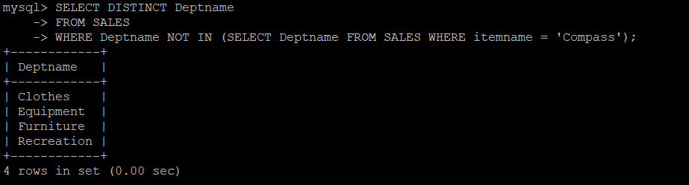

47)SELECT D.Deptname, D.Deptfloor, AVG(E.Empsalary)

FROM DEPARTMENT D

INNER JOIN EMP E ON D.MgrId = E.Empno

GROUP BY D.Deptname;

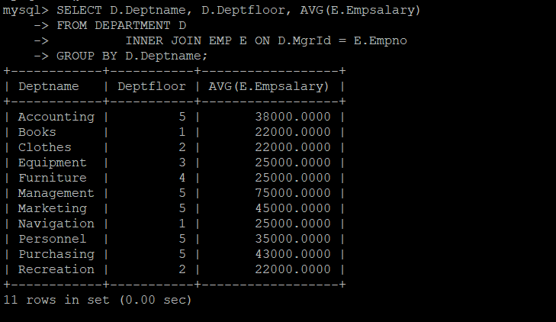

48)SELECT B.Empname

FROM EMP E

INNER JOIN EMP B ON E.Bossno = B.Empno

WHERE E.Empname = 'Nancy';

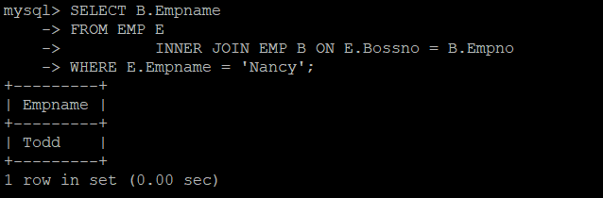

49)SELECT Empno, Empname, EMP.Deptname, Bossno, Empsalary - Average

FROM EMP

INNER JOIN (SELECT Deptname, AVG(Empsalary) AS Average FROM EMP GROUP BY Deptname) A

ON A.Deptname = EMP.Deptname;

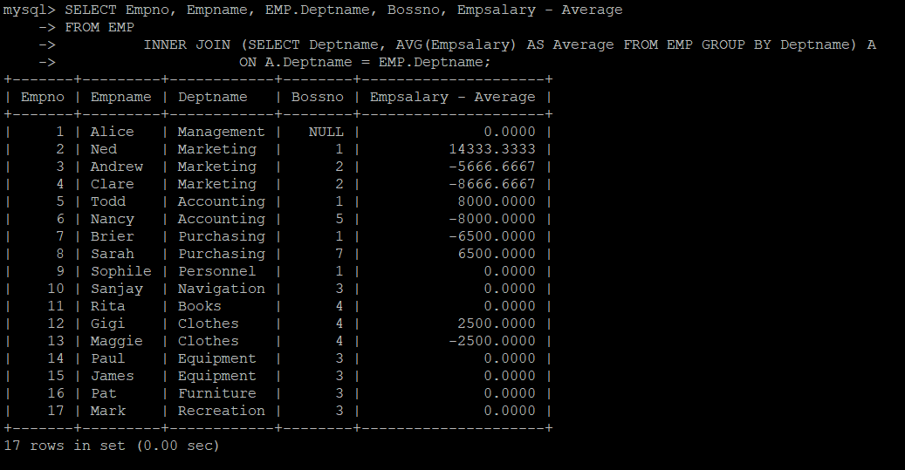

50)SELECT Deptname

FROM EMP

GROUP BY Deptname

HAVING COUNT(*) > 1

AND Deptname IN (SELECT Deptname FROM DEPARTMENT WHERE Deptfloor = 2);

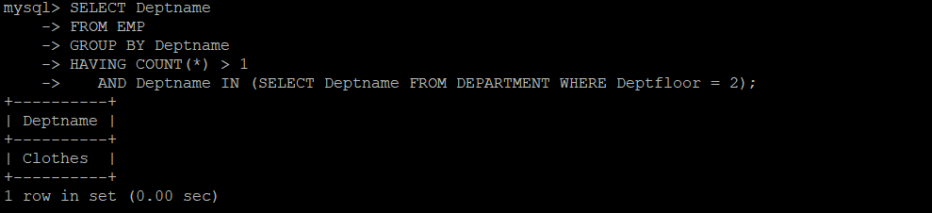

51)SELECT Deptname

FROM DEPARTMENT

WHERE Deptfloor IN (2, 5);

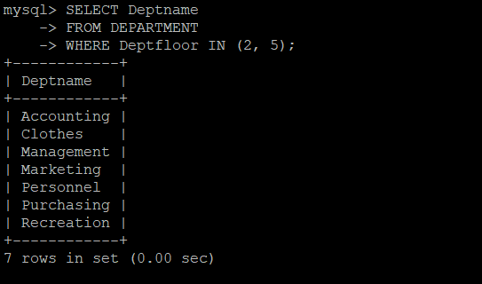

52)SELECT Empname

FROM EMP

WHERE Empsalary > (SELECT AVG(Empsalary) FROM EMP WHERE Deptname = 'Books');

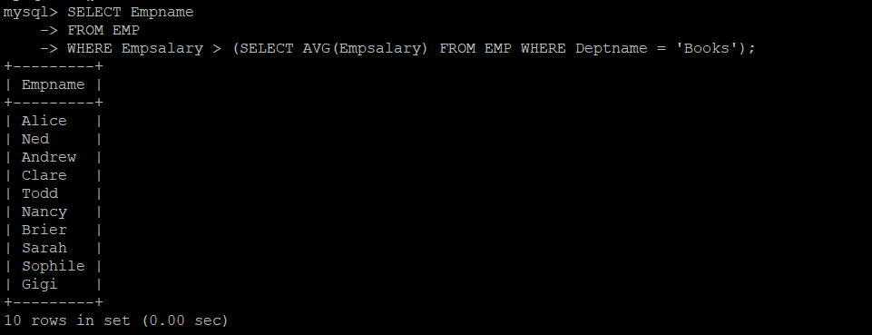

53)SELECT Empname

FROM EMP

WHERE Empno IN (SELECT Bossno FROM EMP GROUP BY Bossno HAVING COUNT(*) = 1);

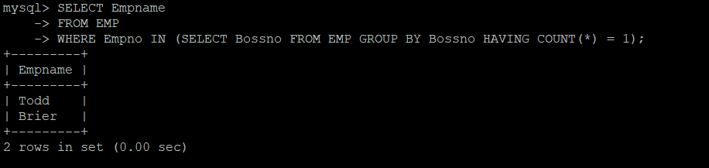

54)SELECT E.Empname

FROM EMP E

INNER JOIN EMP B ON E.Bossno = B.Empno

WHERE B.Empname = 'Todd';

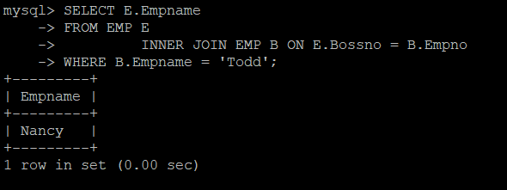

55)SELECT DISTINCT Deptname

FROM SALES

WHERE Deptname NOT IN (SELECT Deptname

FROM SALES S

INNER JOIN ITEM I USING (itemname)

WHERE itemcolor = 'Green'

GROUP BY (S.Deptname)

HAVING COUNT(*) = (SELECT COUNT(*) FROM ITEM WHERE itemcolor = 'Green'));

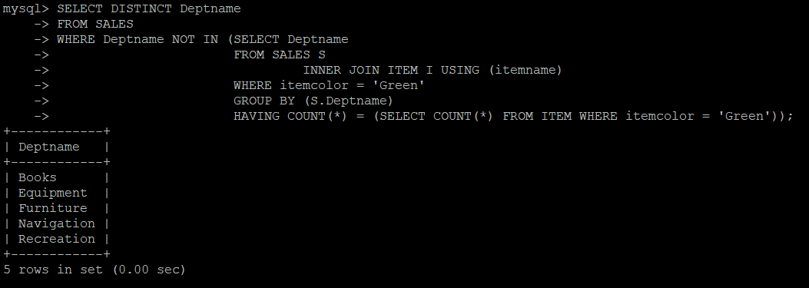

56)SELECT B.Empname

FROM EMP E

INNER JOIN EMP B ON E.Bossno = B.Empno

WHERE E.Empname = 'Sophile';

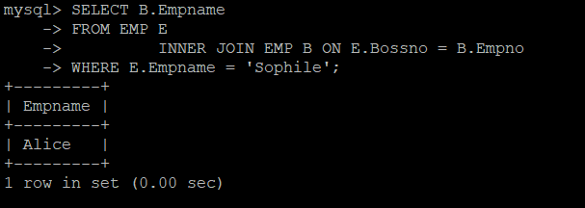

57)SELECT E.Empname

FROM EMP E

INNER JOIN EMP B ON E.Bossno = B.Empno AND E.Empsalary < B.Empsalary / 2;

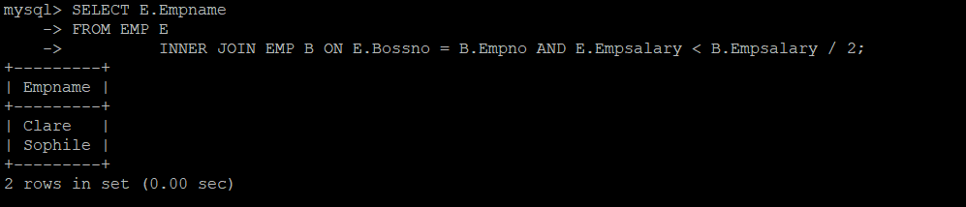

58)SELECT B.Empname AS Manager, E.Empname AS Employee

FROM EMP E

INNER JOIN EMP B ON E.Bossno = B.Empno;

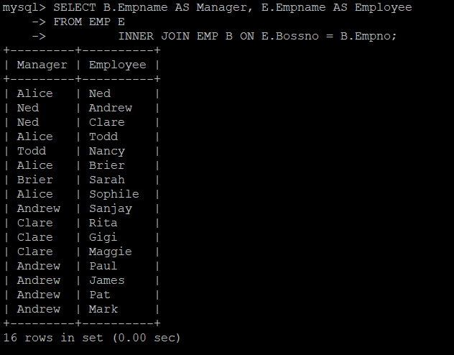

59)SELECT Empname

FROM EMP

ORDER BY Empsalary

LIMIT 1;

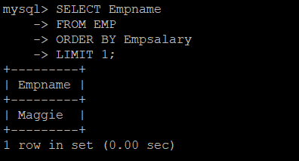

60)SELECT Empname

FROM EMP

WHERE Empsalary < (SELECT MIN(Empsalary) FROM EMP WHERE Deptname = 'Marketing');

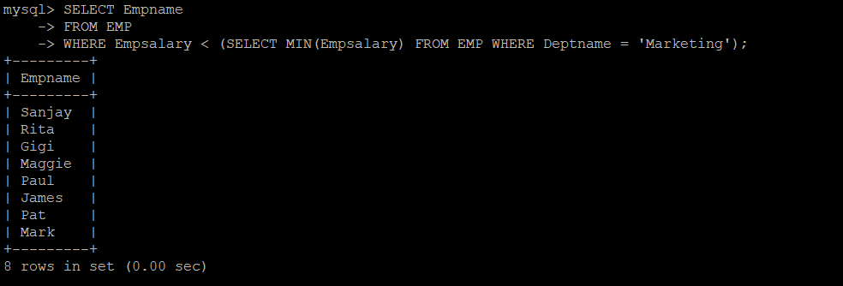

61)SELECT DISTINCT S.itemname

FROM SALES S

INNER JOIN ITEM I ON S.itemname = I.itemname AND I.itemcolor = 'Brown';

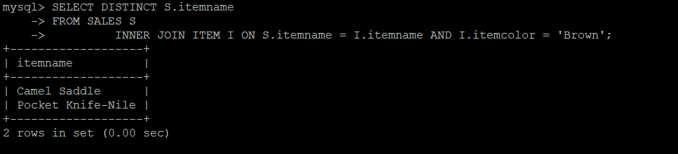

62)SELECT DISTINCT S.itemname

FROM SALES S

INNER JOIN ITEM I ON S.itemname = I.itemname AND I.itemcolor = 'Brown'

WHERE S.Deptname = 'Books';

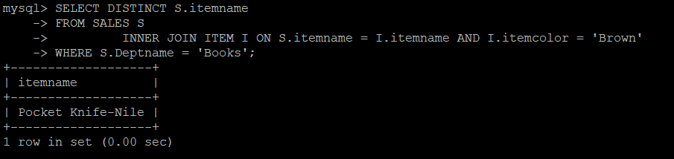

63)SELECT Deptname

FROM EMP

GROUP BY Deptname

ORDER BY AVG(Empsalary) DESC

LIMIT 1;

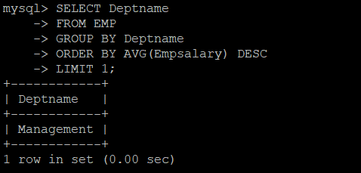

64)SELECT Deptname

FROM SALES S

INNER JOIN ITEM I ON S.itemname = I.itemname AND I.itemcolor = 'Brown'

GROUP BY (Deptname)

HAVING COUNT(*) = (SELECT COUNT(*) FROM ITEM WHERE itemcolor = 'Brown');

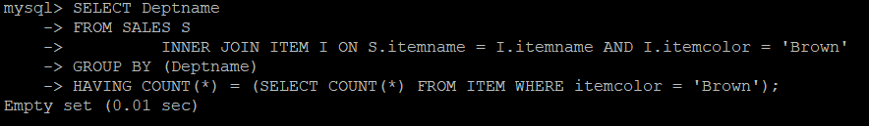

65)SELECT Deptname, AVG(Empsalary)

FROM EMP

WHERE Deptname IN (SELECT DISTINCT Deptname FROM SALES WHERE itemname = 'Sextant')

GROUP BY Deptname;

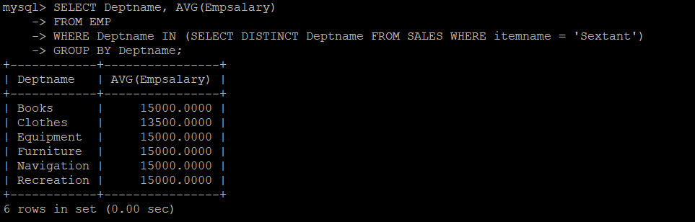

66)SELECT itemname

FROM SALES

GROUP BY itemname

HAVING COUNT(DISTINCT Deptname) >= 2;

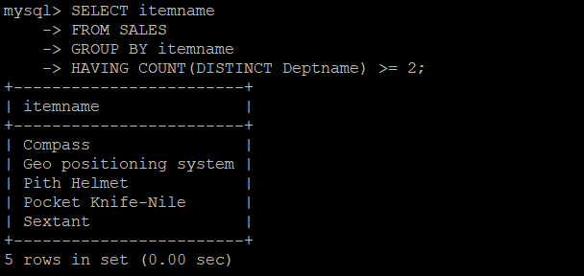

67)SELECT B.Deptname

FROM EMP E

INNER JOIN EMP B

WHERE E.Bossno = B.Empno

GROUP BY B.Empno

HAVING AVG(E.Empsalary) > 25000;

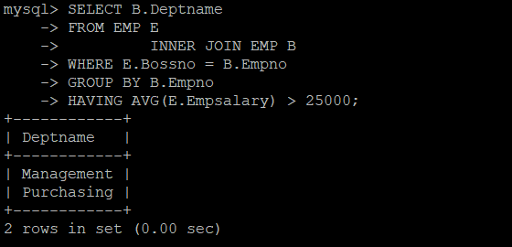

68)SELECT Deptname

FROM SALES

WHERE itemname = 'Stetson'

AND Deptname IN (SELECT Deptname FROM EMP GROUP BY Deptname HAVING SUM(Empsalary) > 25000);

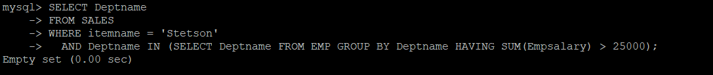

69)SELECT itemname, D.Deptname, Deptfloor, Empname

FROM SALES S

INNER JOIN DEPARTMENT D USING (Deptname)

INNER JOIN EMP E ON D.MgrId = E.Empno;

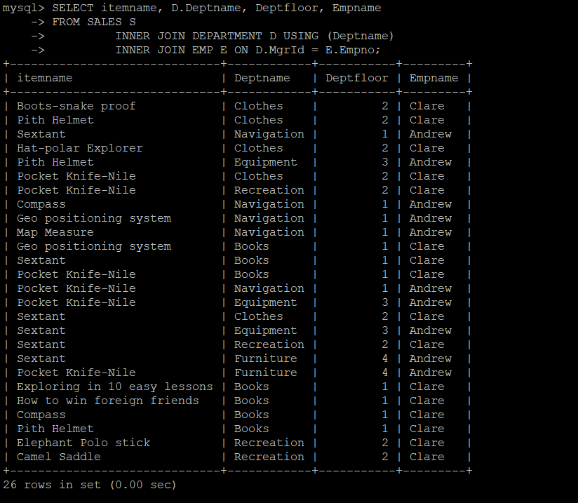

70)SELECT DISTINCT itemname

FROM SALES S

INNER JOIN DEPARTMENT D USING (Deptname)

WHERE Deptfloor != 2;

